**ANKLE STRENGTHENING PROGRAM**

**EQUIPMENT NEEDED:** Resistance Band **PERFORM:** Work up to 3 Sets of 15

each foot

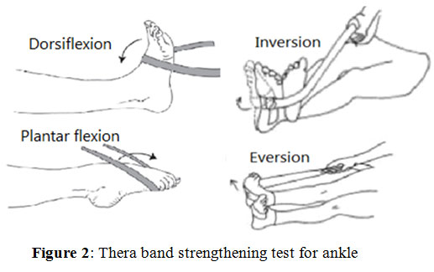

**Single-Leg Heel Raise**:Work up to 3 sets of 10

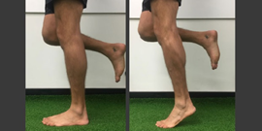

*\*\*Progress with Dumbbells* – You can do this single-legged or both legs at the same time. Work up to 3 sets of 10 before increasing the weight.

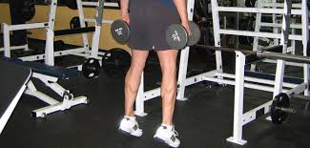

**BALANCING PROGRAM = Do 3x/week; Strengthens Ankles & Increases Proprioception. DO BOTH FEET!**

**Single Leg Balance (SLB):** Stand on 1 foot on flat surface & hold for 30s; Switch feet & Repeat 3x!

**SLB With Eyes Closed:** Stand on 1 foot on stable surface. Close your eyes. Balance for 30s; Repeat 3x!

**SLB on Unstable Surface:** Stand on a pillow or couch cushion. Perform SLB for 30s; Repeat 3x!

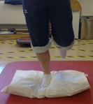

**SLB & Touch the Ground:** While balancing, lean forward and try to touch the ground and stand back up. Work up to 3 sets of 10 for each foot.

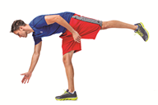

**SLB with a Catch:** Make this sports-specific! Grab a tennis ball (or other ball that bounces) against the wall and catch it while performing your SLB. Have a catch with a friend – make them challenge you by throwing the ball back to you. Progress to having a catch while balancing on your pillows again! Small weighted medicine balls work too and are good for progression.

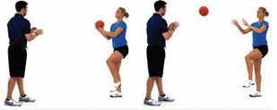

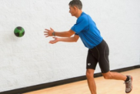

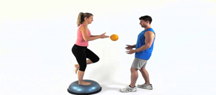

**FOAM ROLL/MASSAGE & STRETCH WHEN YOU ARE DONE!**

***Foam Roll/Massage for up to 5 minutes for each listed below.***

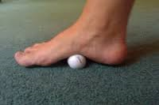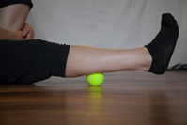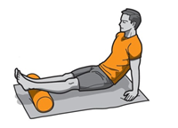

***Perform the following stretches: 3x for 20 seconds for each leg!***



