Activity 5.2 Straw Rocket Activity

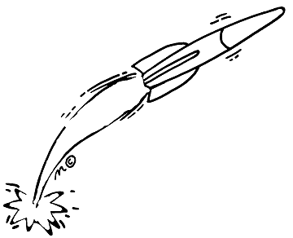

Course: 5th Grade Design and Engineering

Student: _______________________________________________________

Section: _____________________________ Period: _______________

Activity 5.2 Straw Rocket Activity Design Brief

**Background Scenario**: You are an Aeronautical Engineer who works for NASA (The National Aeronautical and Space Administration. You are a member of a team who has been working on developing a long-range rocket which will carry a number of astronauts and their equipment to Mars. The Mars Rocket will be carrying transportation vehicles but fuel supplies are VERY limited so landing the rocket close to the “target zone” is extremely important. The Mars Rocket is nearly complete and ready to launch but NASA is concerned about how close your team can “land” the Mars Rocket to the “target zone”. So now you and your team will design and model a series of “test rockets” to practice the Mars landing procedures.

**Materials:** **Tools/Equipment**:

1 Plastic Straw Pencil

1-2 Index card(s) Ruler

Clay Scissors

Masking Tape Triple Beam Balance

**Problem Statement**: Using only the given materials listed above, create a rocket which when launched from a given launch area successfully lands in the designated "target area".

**Parameters**:

* The straw body of the rocket must remain 20 cm long.
* The finished rocket must contain 2, 3, or 4 fins physically attached to the rocket itself.
* The nosecone (clay) may not weigh more than 10 grams.

**Variables**: Each student may change or alter the following:

* The Size and Shape of the Fins
* The Total Number of Fins (2,3, or 4)
* The Weight of the nosecone
* Both the Launch Angle and Launch Magnitude of the Launcher.

**Pre-testing Procedure**: Each student will be given appropriate lab time to test and re-test their preliminary design ideas before selecting and creating their final design idea. (5 attempts per student to start)

**Final Testing Procedure**: During the Final Testing Phase, each student will be given three (3) attempts to "land" their rocket in the "target area".

Time to THINK! - *Using the information in the Design Brief above, answer the following questions.*

*1) What item listed in the materials list do you think you will use for the rocket's body?*

*2) Can the pair of scissors be used as part of the rocket?*

*3) Restate one of the three variables that the students will be able to alter or change?*

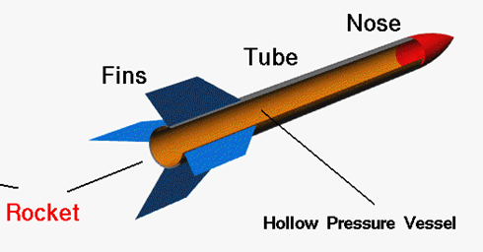Related Information:

**Nosecone**

**Main Parts of a Rocket**

Key Terms:

Force - An __________________ between masses; a push or ________________.

Launch Angle - The _____________, measured in degrees, used to set the rocket's intended path (parabola) _______________________________.

Launch Magnitude - The _________________ used at launch to set the rocket into ________________. The greater the force the ____________________________________________.

Model - An explanation or ________________________________________________________, system or process that cannot be easily studied.

Solar System - The ________ and the _____________ and other celestial bodies that orbit it.

Thrust - The ___________________ of a jet or rocket engine.

Variable - A ______________ or function that may or ____________ change.

Velocity - The ______________________ at which an _____________________________________.

Time to THINK! - *Using the vocabulary words listed in the Key Terms section, fill in the blanks with the proper Key Term.*

*1) Since building full-sized rockets is a costly and time consuming process,*

*Engineers often build physical _____________________ to show the look or*

*function of the rocket to use for testing purposes.*

*2) In order to put a rocket into orbit, Engineers must use rocket engines*

*powerful enough to provide enough _______________________ to get the*

*rocket outside of Earth's gravitational forces.*

*3) When a student changes from 3 fins to 4 fins to help with stability this is an*

*example of changing a __________________________.*

*4) Mars is the 4th planet in our ____________________ ___________________.*

*5) If a student's rocket consistently falls short of the target area, the student*

*could try changing the rocket's launch ________________________.* (Two

answers could fit).

*Bonus Question: Which unit of measurement would most likely be used to*

*measure the distance from Earth to the planet Mars?*

Activity 5.1.1 Thumbnail Sketches (Fin Design)

Complete 3 Thumbnail Sketches below: (The first one is completed for you.)





Activity 5.1.2 Final Drawing (Fin Design)

At this point you will need to choose which Fin Design you most want to try. Draw that Final Design Idea below and then cut the Fin Design out with the pair of scissors and then use it as a template to cut out your fins on the index card. The Design boxes are drawn to exact scale so the size and shape you draw below will be the same size as your template. You may want to try more than one Fin Design so you may use the other boxes to create other templates.

Final Design Idea #3

Final Design Idea #2

Final Design Idea #1



Time to Reflect

1. Did you complete the challenge in the allotted tries during final testing (3); meaning was your rocket successful?
2. After having tested your rocket several times during the “open lab” periods, *what was your MOST SIGNIFICANT modification, adjustment or variable you changed* in an attempt to make your rocket successful?
3. What might you *do differently* if you were asked to complete this project again?
4. What might you *do the same* if you were asked to complete this project again?
5. Did you enjoy this project? Why or Why Not?
6. If your rocket continues to fall short of the target zone, what could we increase in order for the rocket to make it to its destination? (Think About Our Science Vocabulary)
7. How many hours would it take a rocket traveling 100 miles per hour heading from Earth to Mars at a total distance of 4,000 miles?