# Create a Student Account

[← Student Management](http://support.teachtci.com/knowledgebase/topics/5497-student-management)

https://teachtci.uservoice.com/assets/74288922/student-sign-in-upper-corner.png

﻿1) Go to [www.teachtci.com](https://teachtci.uservoice.com/admin/faqs/90476/www.teachtci.com).

2) Click on the purple "Student Sign In" button (upper right corner)

3) Click on the green "Create Account" button

4) Enter the teacher email, first name, last initial, username and password then confirm your password.

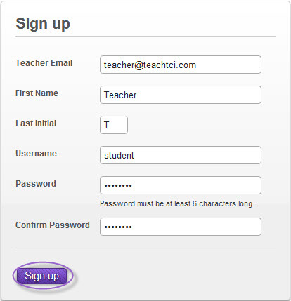

neshaminy

neshaminy

K

James

jpkelly@neshaminy.k12.pa.us