Chapter 46
Redefining Equality
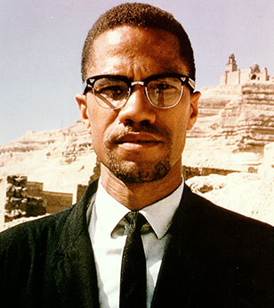 | Date:  Event: The Hate that Hate Produced  Facts:
 | Date:  Event: Watts Riots  Facts:
 | Date:  Event: Black Panther Party  Facts:
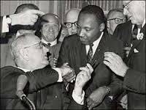 | Date:  Event: Civil Rights Act of 1968  Facts:

Redefining Equality
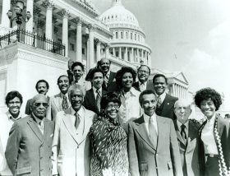 | Date:  Event: Congressional Black Caucus Formed  Facts:
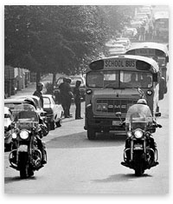 | Date:  Event: Swann v. Charlotte-Mecklenburg Board of Education  Facts:
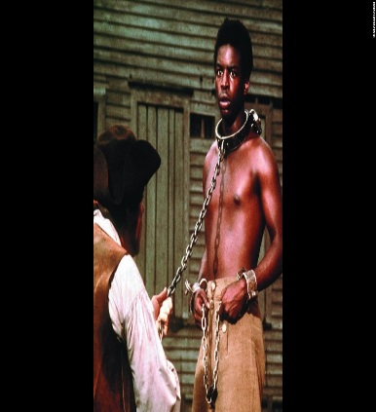 | Date:  Event: Roots Aired  Facts:
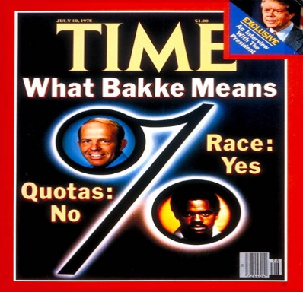 | Date:  Event: Regents of the Univ. of California V. Bakke  Facts:

