NAME: _____________________________________

CLASS: ______________

**Geography Skills**

***Analyze the maps in “Setting the Stage” and your text. Then answer the following questions and fill out the map as directed.*** *Use maps in your textbook on pages 378-382 / page 3 / and the Whiteboard to answer the following questions.*

**USE MAP 1:**

1. Next to the words “MAP 1”, **DRAW the cardinal directions / Compass Rose**. (North, South, East, West)

2. What is the name of the *horizontal line* that divides Earth’s Northern and Southern Hemispheres?

____________________________________________________________

* **DRAW and LABEL the line on MAP 1.**

3. What *vertical* (up and down) line divides the Eastern and Western Hemispheres?

____________________________________________________________

* **DRAW and LABEL the line on MAP 1.**

4. What are the names of the seven continents? _____________________________________________________________________________________________ ______________________________________________________________________________________________ ______________________________________________________________________________________________ * **LABEL the continents on MAP 1 using a *black* pencil.**

* **OUTLINE each continent using *7* different colors.**

5. What are the names of the five oceans? _____________________________________________________________________________________________

**_____________________________________________________________________________________________**

* **LABEL the oceans on MAP 1 using a *blue* pencil.**

6. Find the Mediterranean Sea, Red Sea, Caspian Sea, and Black Sea on your map.

*\** **LABEL the four seas on MAP 1**

7. Find the United States on your map.

\***Label the United States on MAP 1**

**Geography Skills**

**USE MAP 2**

1. In the margins of MAP 2, **DRAW in the cardinal directions / Compass Rose**.

2. Locate the continent of Africa on Map 2 (see text pg. 3)**.**

* **LABEL the continent of Africa.**

3. On which **continent** did they find the earliest human fossils (see text pg. 3)? __________________________

* **DRAW an X on MAP 2 to show where the earliest human fossils have been found.**

4. Which continent is north of Africa? ______________________________

* **LABEL the continent north of Africa on MAP 2**

5.Which continent lies to the northeast of Africa? ______________________________

* **LABEL it on MAP 2.**

* **NAME and LABEL the body of water off the WEST coast of Africa. _______________________________________________**

* **NAME and LABEL the body of water off the NORTH coast of Africa. _______________________________________________**

* **NAME and LABEL the ocean which is located off the EAST coast of Africa.**

**_____________________________________________________**

6.What is the name of theRiver found in Egypt (text pg. 383) _______________________________________

* **LABEL it on MAP 2**

Into which body of water does the River flow? _______________________________________

* **LABEL it on MAP 2**

7. What sea lies to the east of the Nile River (between Africa and Saudi Arabia)? ________________________.

* **LABEL the sea between Africa and Saudi Arabia on Map 2**

***The Fertile Crescent*** *is a boomerang-shaped region that extends from the northern part of Egypt (around the Nile River) and the eastern shore of the Mediterranean Sea to the Persian Gulf. The Fertile Crescent is a rich food-growing area in a part of the world where most of the land is too dry for farming.*

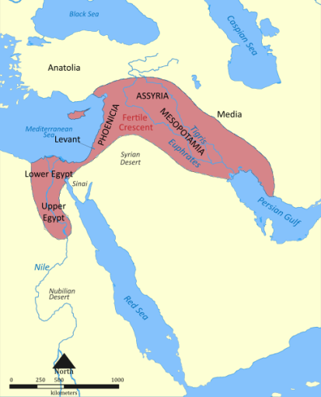

8. Which rivers run through the Fertile Crescent?

__________________________________________

9. Into which body of water do these rivers flow?

__________________________________________

* **LABEL the rivers and the body of water into**

**which they flow on Map 2.**

**Critical Thinking**

Answer the following questions in complete sentences.

1. The earliest settlers settled in North Africa and the Middle East which are very hot and dry. Most of North Africa and the Middle East is desert. How do you this this affected the settlement of early people? Why would they choose to live there?

______________________________________________________________________________________________

______________________________________________________________________________________________

______________________________________________________________________________________________

______________________________________________________________________________________________

2. Considering the geographical physical features such as plains and deserts, why do you think early humans migrated eastward to the Fertile Crescent (see map on the opposite side), rather than north to Europe?

______________________________________________________________________________________________

______________________________________________________________________________________________

______________________________________________________________________________________________

______________________________________________________________________________________________

3. One region in the Middle East is called Mesopotamia (see map on the other side of this paper). This name means the “land between the rivers.” Where do you think this region lies? What is the country’s name?

________________________

4. The Fertile Crescent was made up mostly of grassy plains. While this area was good for farming, it lacked resources such as stone, wood, and metal. What hardships might these shortages have caused for the people who lived there?

______________________________________________________________________________________________

______________________________________________________________________________________________

______________________________________________________________________________________________

______________________________________________________________________________________________

5. Why did most early civilizations develop near a water supply? _________________________________________

______________________________________________________________________________________________

______________________________________________________________________________________________

______________________________________________________________________________________________