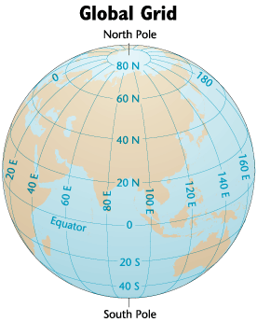

20N, 80E - Latitude is stated first

Absolute Location of Chandrapur, India

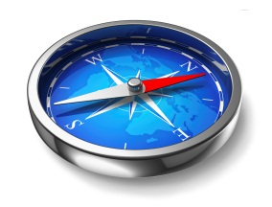

**MAP ELEMENTS**

***Title,*** *L****egend****,* ***Compass Rose, Grid, Scale***

***Absolute vs Relative Location***

**I. Latitude and Longitude / Hemispheres / Global grid**

**Lines of Latitude (Parallels)** *Ex: 60N, 44N, 20S, etc.*

* Imaginary parallel lines that circle the globe and measure distance north or south from the Equator.

**Lines of Longitude (Meridians)** *Ex: 60W, 124W, 28E, etc.*

* Imaginary lines that circle the globe from pole to pole and measure distance east or west from the Prime Meridian. They are also referred to as Meridians.

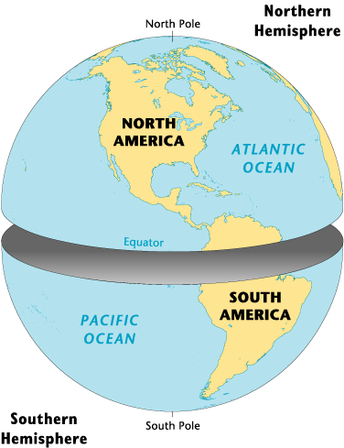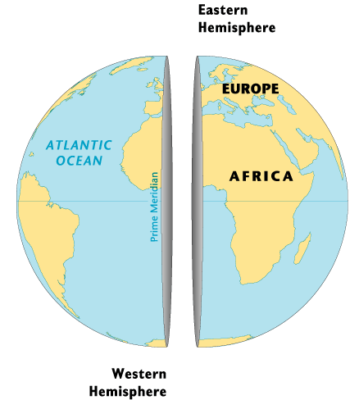

**Four Hemispheres:**

Northern

Southern

Eastern

Western

**II. Absolute vs. Relative Location** *(Where are we?)*

**Absolute Location = EXACT Location.** Doesn’t Change!

**-** The exact location where someone or something is on the Earth. It is usually expressed by latitude and

longitude coordinates or specific street address.

*Examples:* *Langhorne is located at 40◦ N / 74◦ W*

*The White House is located at 1600 Pennsylvania Avenue, Washington, DC 20500*

**Relative Location = CHANGES based on your location.**

**-** The location of a place stated in terms of its relation to another location in both distance and direction

*Examples: Take Langhorne – Yardley Road 1 mile west and turn left at the bank.*

*You are 30 miles North East from The Wells Fargo Center in Philadelphia.*

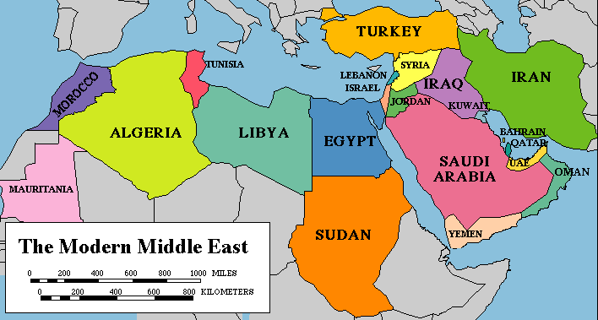

**III. Title**

Defines the purpose of a map and what type of map you are examining.

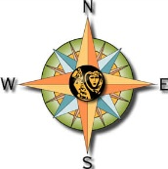

**IV. Compass Rose**

Shows the four cardinal directions and is used to identify direction.

**V. Scale**

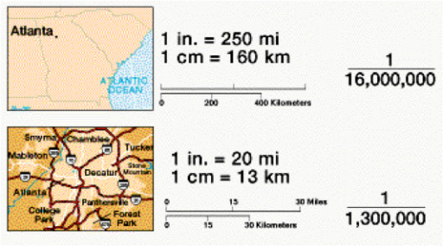A map element that shows the relationship between the portions of Earth being studied

and Earth as a whole. Specifically, the relationship between the size of an object on a

map and the size of the actual feature on Earth's surface.

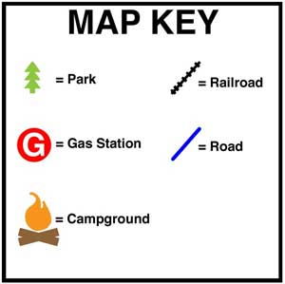**VI. Legend / Key**

A map element which contains a key to all the symbols used on a map.

It explains the meaning of each symbol.