N o t e b o o k H a N d o u t a

Identify the tree in American society during the 1930s. Who is the individual representing in the Cartoon? (Scroll down).

Match a Description; A Quotation; and a Policy to each cartoon (three total).

Three Political Ideologies

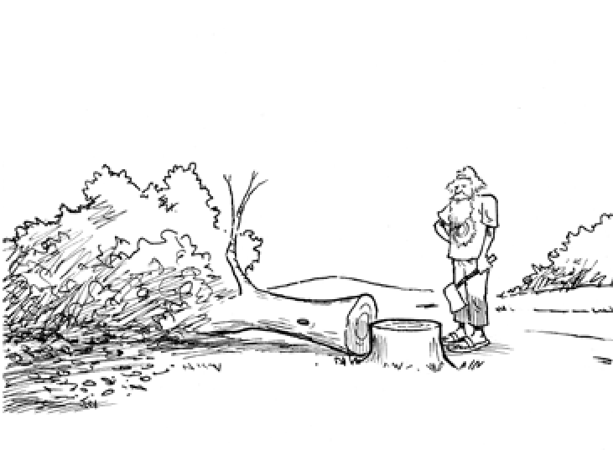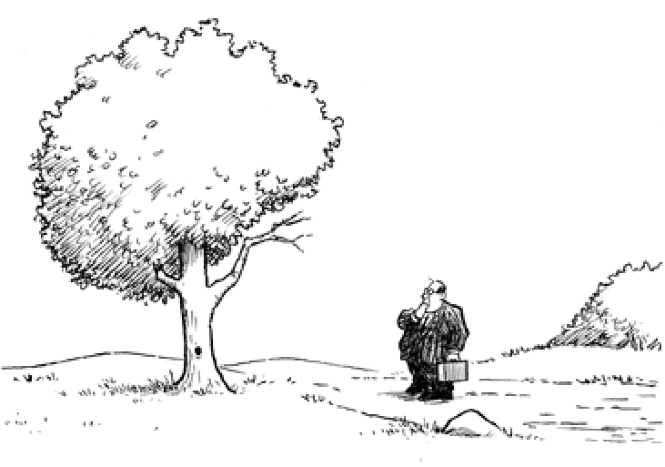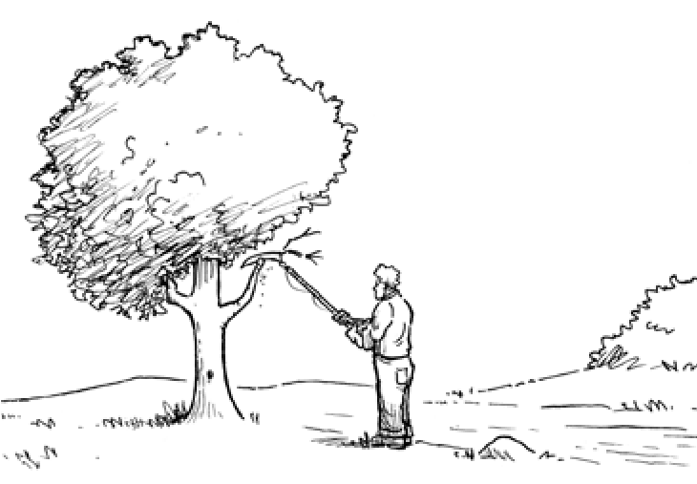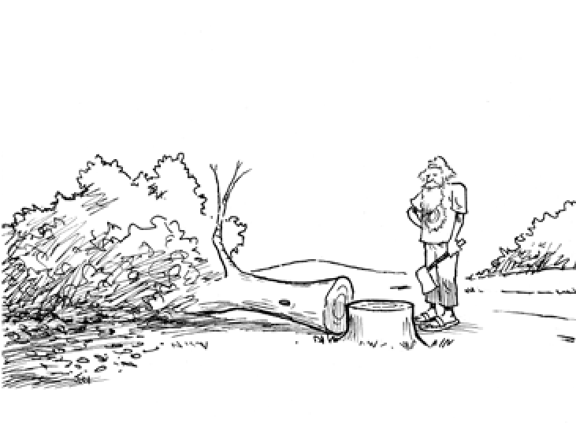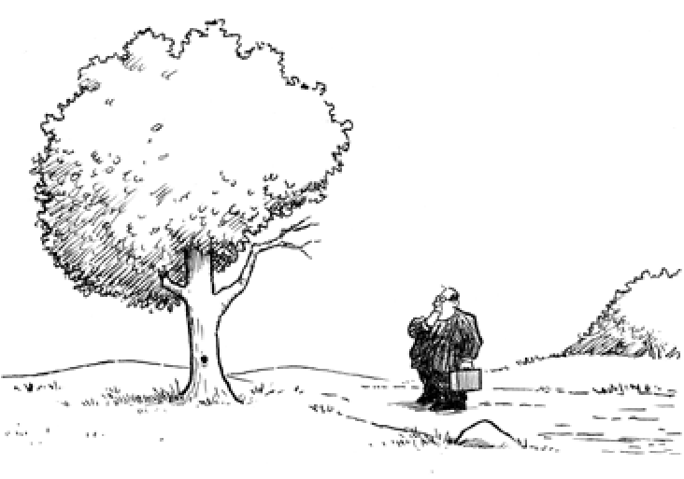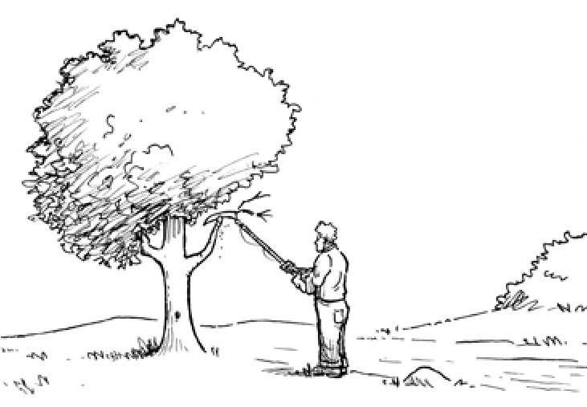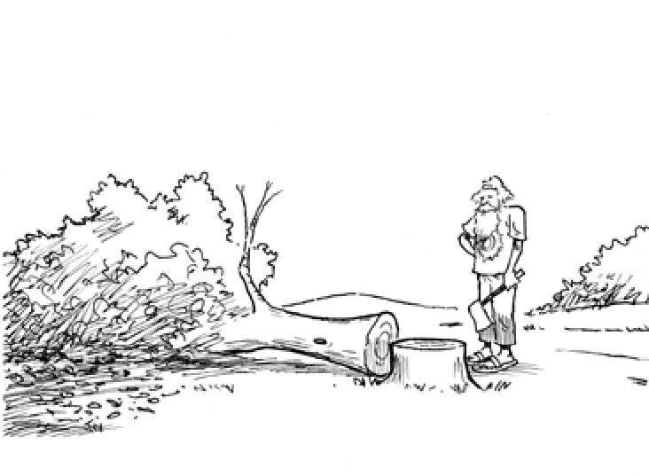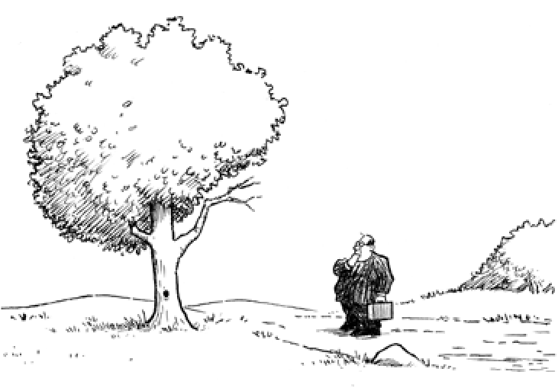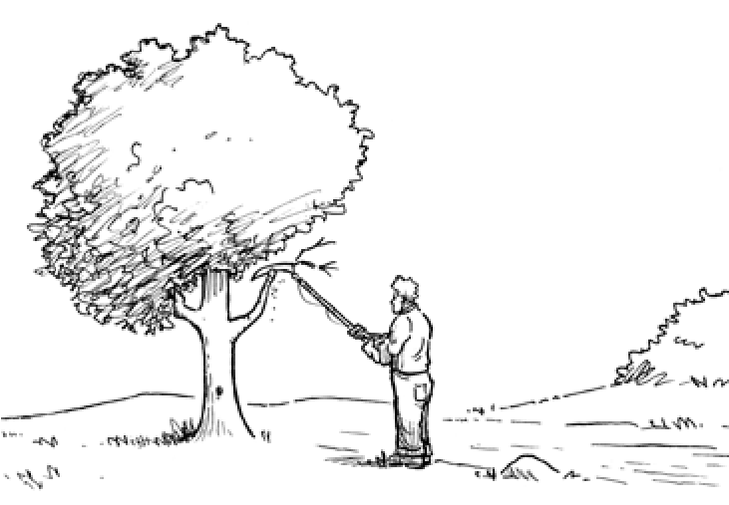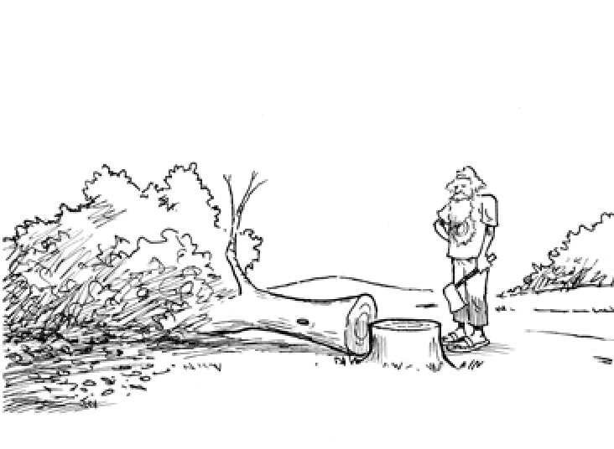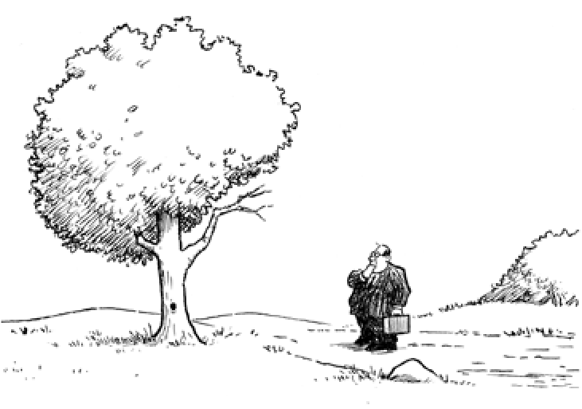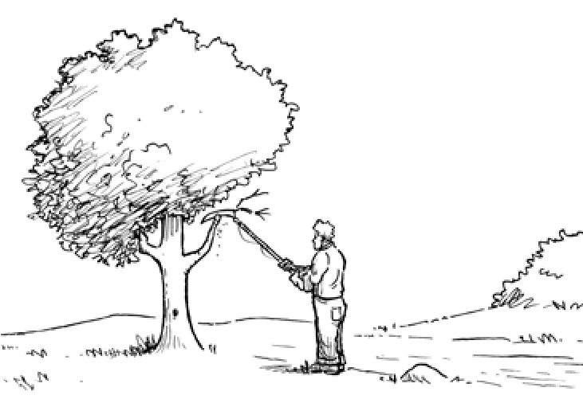

© Teachers’ Curriculum Institute

**1**

the Response to the economic Collapse

!

N o t e b o o k H a N d o u t b

Political Ideology Statements

!

|  |  |  |
| --- | --- | --- |
| **Description A**  this political ideology promotes national regulation of banks, utilities, and transportation as a way of protecting consumers. | **Description B**  this political ideology supports allowing the markets to become stable all by themselves without government interference. | **Description C**  this political ideology supports the federal government in planning all aspects of the economy, including agricultural production, in order to more closely match supply with demand. |
| **Quotation D**  “We propose to limit the amount which any one may earn to $1 million per year . . . throwing all surpluses into the United States treasury. then from the immense money thus acquired we will guarantee to every family a home and . . . automobile and radio.”  —Huey Long, 1935 | **Quotation E**  “I shall ask the Congress for . . . broad executive power to wage a war against the emergency . . . this nation asks for action, and action now . . . We must act and act quickly.”  —Franklin d. Roosevelt, 1933 | **Quotation F**  “I do not believe that the power and duty of the general government ought to be extended to the relief of individual suffering.”  —Herbert Hoover, 1931 |
| **Policy G**  be it enacted . . .the administrator is authorized to make grants to the several States to aid in meeting the costs of furnishing . . . work relief and in relieving the hardship and suffering caused by unemployment.  —Federal emergency Relief act,  1933 | **Policy H**  I, together with other officers of the Government, initiated extensive cooperative measures throughout the country. the first of these measures was an agreement of leading employers to maintain the standards of wages and of labor leaders to use their influence against strife.  —President’s explanation of Policy of Voluntary Cooperation, 1930 | **Policy I**  every family in America should at least own a homestead . . . No family shall own more than three hundred times the average family wealth . . . No family will have an earning of less than around $2,000 to $2,500.  —Proposals of the Share our Wealth Program, 1935 |

© Teachers’ Curriculum Institute the Response to the economic Collapse **2**