US/World History

Chapter 8 Section 3

411-416

NAME:________________________ DATE:_______________

**Lesson Objectives**

**1.** **Describe** how Cold War tensions were intensified by the arms race between the United States and the Soviet Union.

**2.** **Explain** how Eisenhower’s response to communism differed from that of Truman.

**3.** **Analyze** the impact on the United States of significant international Cold War conflicts.

**4.** **Describe** how Cold War tensions were intensified by the space race.

**Academic Vocabulary**

**ideology:** the set of beliefs of a group or a political party

**radioactive:** having or giving off a dangerous form of energy called radiation

**perpetual:** constant; continuing without interruption

**uprising:** a usually violent effort by the people to change the government of a country

**Key Terms**

mutually assured destruction

John Foster Dulles

massive retaliation

brinkmanship

Nikita Khrushchev

Nationalize

Suez crisis

Eisenhower Doctrine

Central Intelligence Agency (CIA)

National Aeronautics and Space Administration (NASA)

**The Arms Race Intensifies Tensions: Text**

1. **Identify Cause and Effect** As you read the texts in this lesson, use the chart below to take notes about the relationship between the United States and the Soviet Union. In the first column, note causes, or reasons for the continuing Cold War and arms race. In the second column, note effects, or outcomes of each cause.

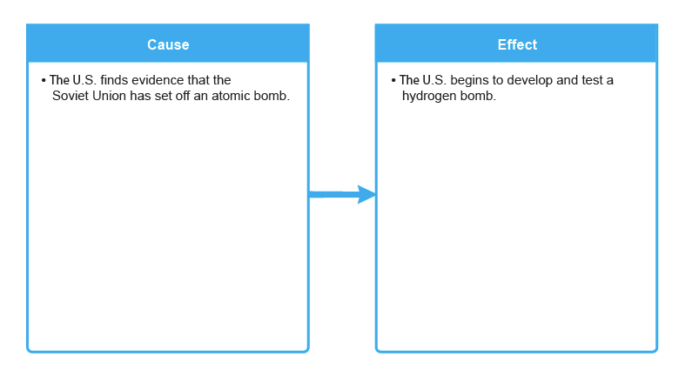

1. **What caused the Cold War to intensify?**
2. Why did the U.S. decide to build the Hydrogen Bomb?
3. What was the “Domino Effect”?
4. How did the concept of Mutually Assured Destruction (MAD) influence the course of the Cold War?
5. How was the CIA used to fight the spread of Communism?
6. How did America react to the launching of the Soviet Satellite “Sputnik”?