
Welcome to 6th Grade General Music!!

Ms. Rhydderch

COURSE OUTLINE & THEME
In this class we will continue to build upon the fundamentals of music that you learned in elementary music and explore new subjects within the realm of music and in conjunction with the Pennsylvania State Standards for Music Education. Our theme this year is American Folk Music. We will incorporate many aspects of this genre in our studies.

CONTENT STUDIED THIS SEMESTER
Music Fundamentals, Reading and Writing Rhythm & Pitch
Instruction and Performance on percussion instruments & keyboards
The Study of American Folk Music within a Cultural Context
Music from the Medieval & Renaissance Eras
Study of Musical Genres in America

COURSEWORK
There will be work sheets, homework, quizzes, and tests for this class to determine your grade for each marking period. Clinics are available if extra help is needed in music.

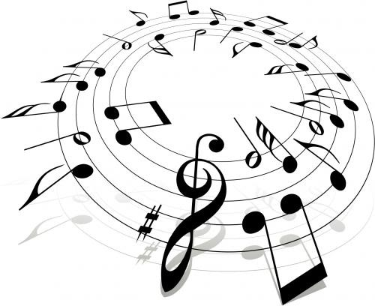
MATERIALS
Students are required to bring in a folder by __________ for your first grade of the semester. I will not allow an extension on this assignment. You must come to class prepared daily with pencils and paper for your notebook. You will also be purchasing a recorder for our Recorder unit for $3 from the Music Boosters.

EXPECTATIONS
Students are expected to participate appropriately in class and complete all work in the time frame given. Ample time will be given for each assignment and almost all work is done in class. If you or your parents/guardians have any questions or concerns about general music this semester please feel free to contact me via email hrhydderch@neshaminy.k12.pa.us ☺

I look forward to having a wonderful semester with you! ROCK ON!! → Ms. Rhydderch


Welcome to 7th Grade General Music!!

Ms. Rhydderch

COURSE OUTLINE & THEME
In this class we will continue to build upon the fundamentals of music that you’ve learned in 6th grade and explore new subjects within the realm of music and in conjunction with the Pennsylvania State Standards for Music Education. Our theme this year is World Music. We will incorporate many aspects of this genre in our studies.

CONTENT STUDIED THIS SEMESTER
Music Fundamentals, Reading and Writing Rhythm & Pitch, Instruction and Performance on percussion instruments & keyboards, The Study of World Music within a Cultural Context
Music from the Medieval, Renaissance, and Baroque Eras, Study of Musical Genres in America
Introduction to guitar and other various music activities

COURSEWORK
There will be work sheets, homework, quizzes, and tests for this class to determine your grade for each marking period. . Clinics are available if extra help is needed in music.

MATERIALS
Students are required to bring in a folder, writing utensils, and blank sheets of paper by ___________. I will not allow extensions on this first assignment.

EXPECTATIONS
Students are expected to participate appropriately in class and complete all work in the time frame given. Ample time will be given for each assignment as most work is done in class. If you or your parents/guardians have any questions or concerns about general music this semester please feel free to contact me via email hrhydderch@neshaminy.k12.pa.us ☺

I look forward to having a wonderful semester with you! ROCK ON!! → Ms. Rhydderch


Welcome to 8th Grade General Music!!

Ms. Rhydderch

COURSE OUTLINE & THEME
In this class we will continue to build upon the fundamentals of music that you’ve learned in 7th grade and explore new concepts within the realm of music and in conjunction with the Pennsylvania State Standards for Music Education. Our theme this year is American Music after the 1900’s. We will incorporate many aspects of this genre in our studies.

CONTENT STUDIED THIS SEMESTER
Music Fundamentals, Reading and Writing Rhythm & Pitch, Instruction and Performance on percussion instruments & keyboards, The Study of American music within a Cultural Context
Music from the Baroque, Classical, & Romantic Eras, Study of Musical Genres in America
Guitar Instruction and other various music activities

COURSEWORK
There will be work sheets, homework, quizzes, and tests for this class to determine your grade for each marking period. . Clinics are available if extra help is needed in music.

MATERIALS
Students are required to bring in a folder, writing utensils, and blank sheets of paper by ___________ for their first grade of the semester. There will be no extension on this assignment. Students must come prepared to music every class.

EXPECTATIONS
Students are expected to participate appropriately in class and complete all work in the time frame given. Ample time will be given for each assignment. If you or your parents/guardians have any questions or concerns about general music this semester please feel free to contact me via email hrhydderch@neshaminy.k12.pa.us ☺

I look forward to having a wonderful semester with you! ROCK ON!! → Ms. Rhydderch

