Early Humans and the Rise of Civilization Word Splash
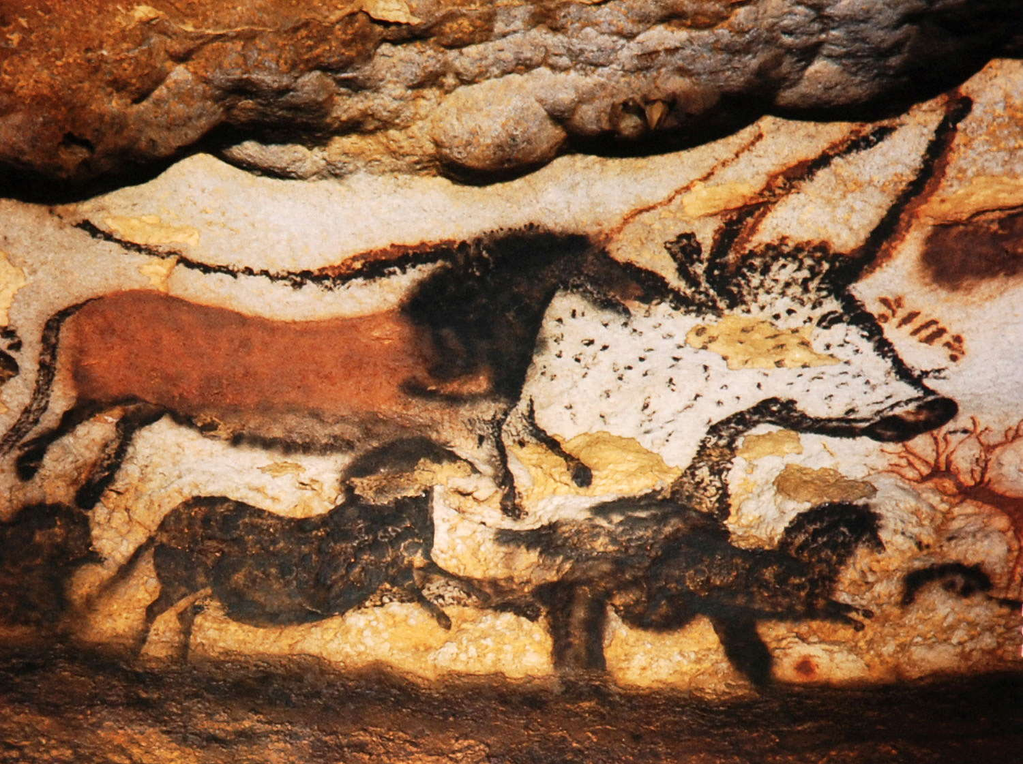
With each of the words below, write a story using your imagination. Attempt to use each word correctly in its proper context. Underline each word used. Circle any word you are not sure of the meaning. Your story must be 10 lines in length. You will receive 5 points for completing this assignment. When you are finished turn to a neighbor and read your story to each other out loud.

Cave painting skeleton anthropologist migrate
Intelligence Neolithic Age agriculture trade
City-state Sumer merchant empire

1.______________________________________________________________________

2.______________________________________________________________________

3.______________________________________________________________________

4.______________________________________________________________________

5.______________________________________________________________________

6.______________________________________________________________________

7.______________________________________________________________________

8.______________________________________________________________________

9.______________________________________________________________________

10._____________________________________________________________________

11._____________________________________________________________________

12._____________________________________________________________________

