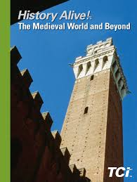
Medieval World and Beyond
500 - 1500
Mrs. Scott - 7th Grade - Room 104
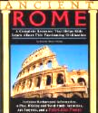
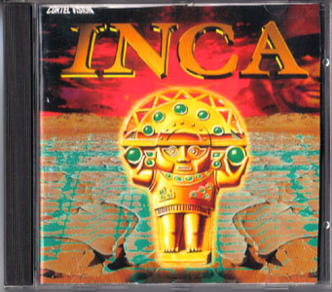
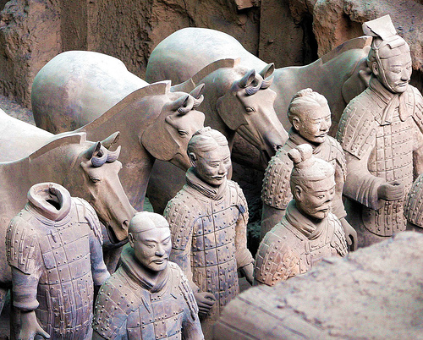
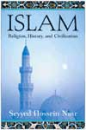
CHINA

I Interactive Spiral Notebook:
Page 3 – Classroom grading and procedures
Page 8-11 – Grades info/Grades will be available on Neshaminy Access Site
Page 12 – Curriculum Starts
Please be aware that the students are given the opportunity to write down the Warm up Question, Learning Target, and Homework every day.
II You Can Monitor Your Child’s Progress
At any time a parent may go to the last page written on in the notebook and start paging backwards…
If any pages have comments written in (such as: X, Not Done or Inc) or they have blank pages… then you know they are not completing the homework or the classwork. Please encourage them to finish all work despite my comments…they need this information for the chapter quizzes, tests, and district exams.
****They could also get ½ credit for the work that is made up within one week.
I collect/grade spiral many times throughout the marking period and then
update grades on the Neshaminy Home Access Center.
III Help I am available at Clinic (Tues.+ Thurs. 7:25), WIN,+ Lunch by appt.
IV Units of Study
Intro: Geography Review Unit 1: Unit 1: Europe During Medieval Times
Unit 2: Islam in Medieval Times Unit 3: The Culture and Kingdoms of West Africa
Unit 4: Imperial China Unit 5: Civilizations of the Americas
V Homework: Homework is posted most nights on my website.

Homework provides opportunities for reinforcement of work learned during school time and encourages children to become independent learners. All students should be writing down their homework in their Agenda each class. Please check to see that they are completing work in their spiral and do not have any blank pages or “Xs” or “not done.”
So tell the kids the dog can’t get blamed :-)
Do you have any questions or concerns?
Contact me: lscott@neshaminy.k12.pa.us 215-809-6210
Please allow 48 hours for me to respond ~ Thank You

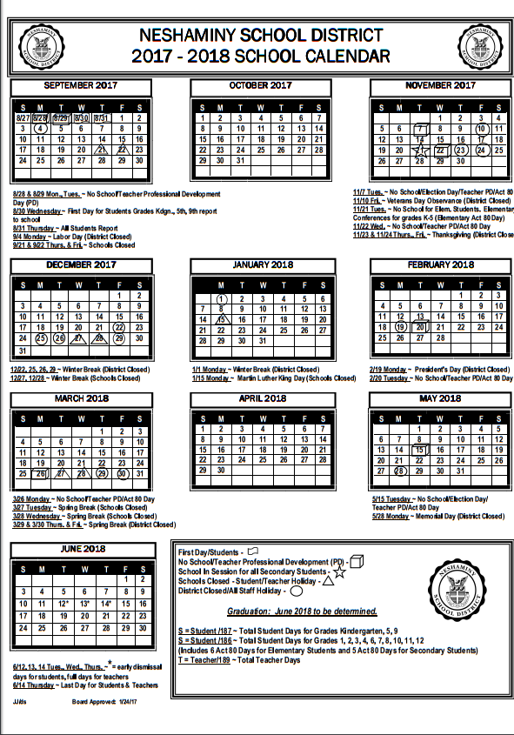
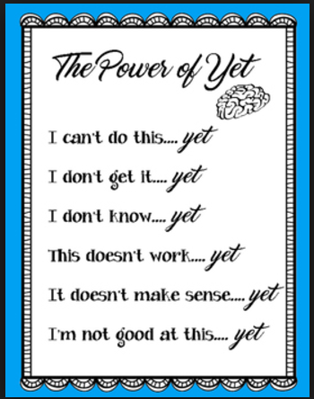
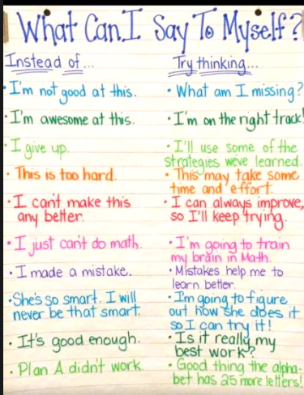
In Social Studies we will be talking about the…
POWER OF YET ☺

