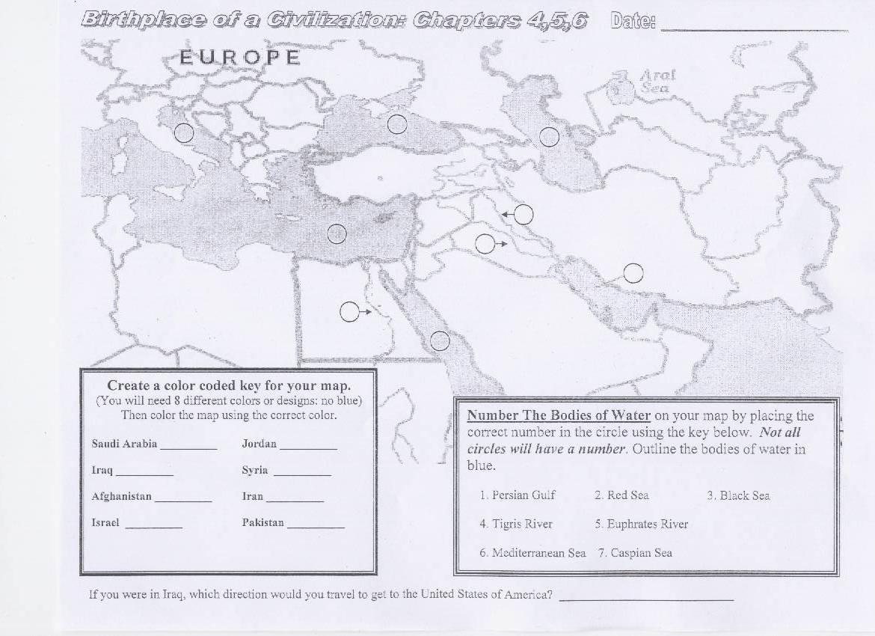
Saudi Arabia
Iraq
Iran
Afghanistan
Pakistan
Israel
Jordan
Syria
1
2
3
4
5
6
7

