How to Create a Notecard

Example:

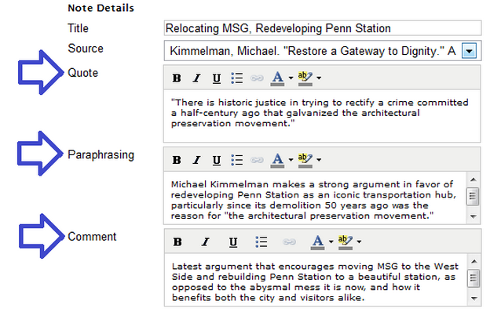

For **“title”**, create an appropriate title for that specific notecard, not for your entire research paper. So if the information on that card is about a job’s salary, then you may want to write “Salary” as your title.

Where it says **“source”**,just leave it blank. It only works if you create your works cited page first.

For **“direct quote”**, copy and paste any info you would like to use in your research paper that you found on a website, journal article, magazine article, etc. Do not copy and paste more than two sentences. Just create a new notecard for more information!

For **“paraphrasing**”, write what you copied in the direct quote section **in your own words.**

Where it says **“comment”**, you can either leave it blank or simply write yourself a note to remind yourself later about this article. For example, you could write “Graph included with important info on this site.”

Where it says **“identifier”** (not listed above), copy and paste the URL of the website you’re using. If you’re using a book or an interview, leave it blank.