THE BEGINNING OF THE LIFE CYCLE

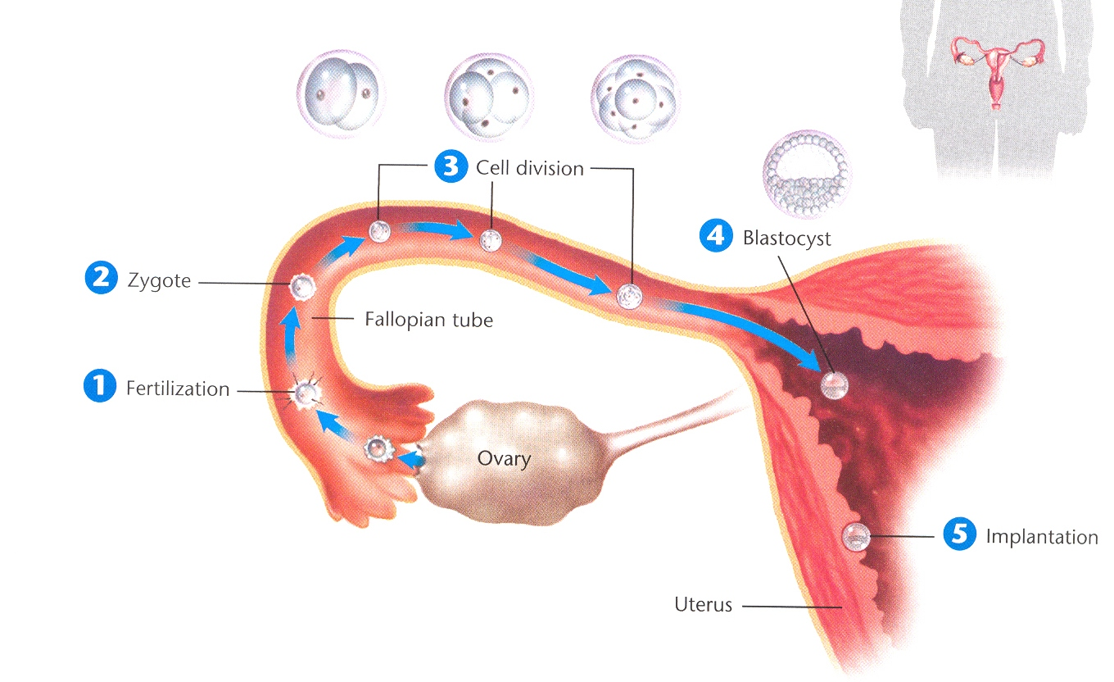

|  |  |
| --- | --- |
| **PHASE** | **DESCRIPTION** |
| 1 |  |
| 2 |  |
| 3 |  |
| 4 |  |
| 5 |  |

DEVELOPMENT IN THE UTERUS

|  |  |
| --- | --- |
| **TERM** | **DESCRIPTION** |
| Amniotic Sac |  |
| Placenta |  |
| Umbilical Cord |  |
| Embyro |  |
| Fetus |  |
| Ultrasound |  |

SIGNS OF PREGNANCY

STAYING HEALTHY

COMPLICATIONS

|  |  |
| --- | --- |
| **TERM** | **DESCRIPTION** |
| ECTOPIC PREGNANCY |  |
| MISCARRIAGE |  |
| PREECLAMPSIA |  |
| GESTATIONAL DIABETES |  |
| PREMATURE BIRTH |  |