**DRUG PROJECT 2016**

**DIRECTIONS:**

**PAGES 3 – 8: Drug Fact Sheets:** You will be creating a fact sheet for the following drug categories:

1. Central Nervous System (CNS) Depressants: These are drugs that slow down the operations of the body. Examples include: Anti-Anxiety Medication (Xanex, Valium, Prozac), GHB, Rohypnol and other anti-depressants (Zoloft, Paxil)
2. CNS Stimulants: These are drugs that accelerate heart rate, elevate blood pressure, and “speed up” the body. Examples are Cocaine, Crack, Amphetamines, and Methamphetamine.
3. Hallucinogens: These drugs can cause the user to perceive things differently than they actually are. Examples are LSD, Peyote, Ecstasy.
4. Narcotics: These drugs relieve pain, induce euphoria and create mood changes in the user. Examples include heroin, Opium, Codeine, Methadone, Vicodin, OxyContin and Percocet.
5. Inhalants: These drugs are breathable substances that produce mind altering effects. Examples: include Toluene, plastic cement, paint, gasoline, paint thinners and hairsprays.
6. Cannabis: This is the scientific name for marijuana. The active ingredient is delta-9-tetrahydrocanninol, or THC. This category also includes synthetic versions of this drug.

See example on Alcohol for questions and information that is necessary on the fact sheet.

**PAGE 9:** Go to the following link <http://www.drugfreeworld.org/#/interactive> and follow the prompts for each box. You will be reviewing the booklet for each category listed. Answer the questions provided on the worksheet.

**PAGE 10:** Define Addiction. Then go to <https://www.discoveryplace.info/stages-addiction> and read about the Stages of Addiction. Describe each stage of addiction in the space provided.

**PAGE 11:** Part 1: Describe how Biology, Environment, and Development influence addiction. Use the link provided.

Part 2: Use the link provided to explore what happens to the brain during addiction.

**PAGE 12:** Use the website provided to analyze the difference between the physical and psychological aspects of addiction. Why do some people become addicted and others do not?

**PAGE 13:** The Road to Recovery: Follow the 6 steps to recovery found at [www.recovery.org/topics/the-addiction-recovery-process/](http://www.recovery.org/topics/the-addiction-recovery-process/) and answer the questions provided for each step.

**PAGE 14:** This page will help you to explore local treatment options for addiction. Visit malverninstitute.com to explore adult treatment options and pyramidhealthcarepa.com to explore adolescent treatment options.

**PAGE 15:** Your Reaction. Choose one of the following prompts and write your reaction. Include your feelings as well as ideas and suggestions.

**This reaction paper should be one page and completed inside the text box.** Highlight the prompt you are writing about.

* What part(s) of the project did you find useful? How can it be improved to help others?
* What part of the project affected you more than the other? How so?
* What information can you take away that is helpful to you and others you may know?

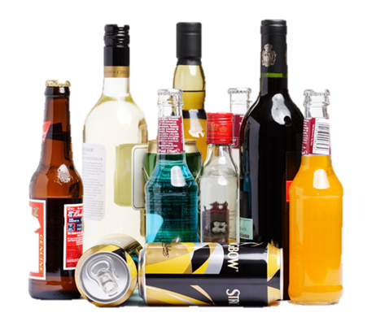

**Signs of Overdose:**

Critical Signs and Symptoms of Alcohol Poisoning

• Mental Confusion /Stupor /Inability to wake up

• Seizures

• Slow Breathing

• Irregular Breathing

• Hypothermia

• Intensive Vomiting

Risks of Use:

• Unintentional Injuries

• DUI / Car Accidents

• Alcohol Poisoning

• Unintentional Pregnancy

• Sexually Transmitted Disease /AIDS / Rape

• Relationship Risks

Indicators of Intoxication:

• Impaired judgement

• Slurred Speech

• Blurry Vision

• Upset Stomach / Diarrhea

• Vomiting

• Breathing Difficulties

• Drowsiness

• Smell of Alcohol on Breath

• Blackouts

**How is it made?**

**Where does it come from?**

Alcohol is made from the fermentation of fruit or grain mixtures (beer), and can then be followed up with distillation of the fermented fruit or grain (hard liquor, wine)

How long do the effects last?

Effects last up to 2 hours after consumption and in urine for 12-24 hours later.

Long Term Effects on the Body:

• Unintentional Injuries

• High Blood Pressure / Stroke

• Heart Disease

• Liver Disease / Ulcers

How is the drug brought into the body?

• Drink

• Tampons

• Beer Bongs

• Squeeze applesauce

What is the drug? Ethanol is the key ingredient in drinking alcohol. Alcohol is mixed with other fluids to create drinks. These range in alcohol content from 2% - 60%. Beer typically contains 2% - 20% and hard liquor from 40% - 60%.

AKA: BOOZE, BREW, handle, 40, Cold-one, JUICE

What is the drug?

**Signs of Overdose:**

• 

Risks of Use:

•

Indicators of Intoxication:

•

**How is it made?**

**Where does it come from?**

How long do the effects last?

Long Term Effects on the Body:

•

ONE PICTURE of the drug

How is the drug brought into the body?

AKA:

What is the drug?

**Signs of Overdose:**

• 

Risks of Use:

•

Indicators of Intoxication:

•

**How is it made?**

**Where does it come from?**

How long do the effects last?

Long Term Effects on the Body:

•

ONE PICTURE of the drug

How is the drug brought into the body?

AKA:

What is the drug?

**Signs of Overdose:**

• 

Risks of Use:

•

Indicators of Intoxication:

•

**How is it made?**

**Where does it come from?**

How long do the effects last?

Long Term Effects on the Body:

•

ONE PICTURE of the drug

How is the drug brought into the body?

AKA:

What is the drug?

**Signs of Overdose:**

• 

Risks of Use:

•

Indicators of Intoxication:

•

**How is it made?**

**Where does it come from?**

How long do the effects last?

Long Term Effects on the Body:

•

ONE PICTURE of the drug

How is the drug brought into the body?

AKA:

What is the drug?

**Signs of Overdose:**

• 

Risks of Use:

•

Indicators of Intoxication:

•

**How is it made?**

**Where does it come from?**

How long do the effects last?

Long Term Effects on the Body:

•

ONE PICTURE of the drug

How is the drug brought into the body?

AKA:

What is the drug?

**Signs of Overdose:**

• 

Risks of Use:

•

Indicators of Intoxication:

•

**How is it made?**

**Where does it come from?**

How long do the effects last?

Long Term Effects on the Body:

•

ONE PICTURE of the drug

How is the drug brought into the body?

AKA:

Go to the following link <http://www.drugfreeworld.org/#/interactive>

and follow the prompts for each box. You will be reviewing the booklet for each category listed.

**PRESCRIPTION DRUGS**

**Why are so many young people turning to prescription painkiller drugs to get “high”?**

**What substance is 30-50 times more powerful than heroin? How many people have been attributed to deaths due to this substance in 2007?**

**What are the most powerful painkillers called? They were manufactured to have what purpose? What are the names of the most powerful painkillers?**

**PAINKILLERS**

**What represents ¾ of the overall problem of prescription drug abuse?**

**What can long term use of painkillers lead to? Briefly describe what that is.**

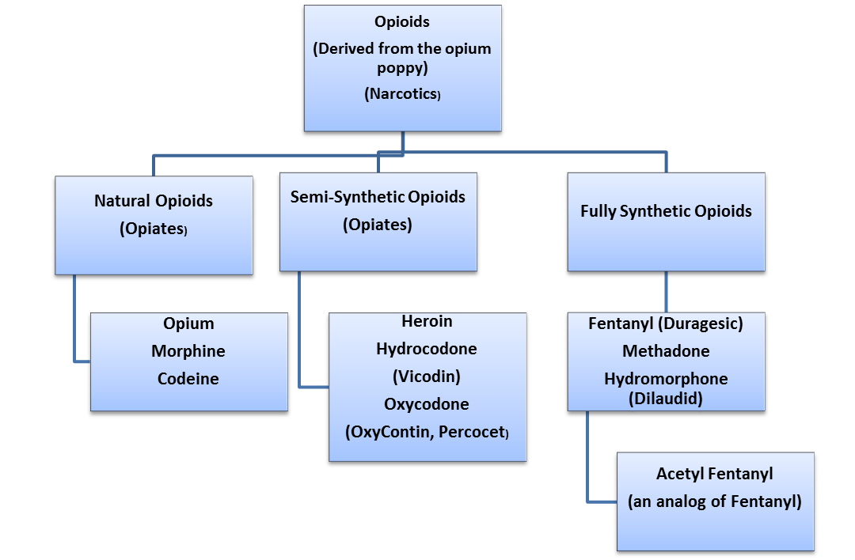

**HEROIN**

**What happened between 1995 and 2002?**

**How does Sabrina describe a day in the life of an addict?**

**Using the chart below describe the connection between the below listed drugs: Codeine, Oxycontin, Heroin and Fetanyl**

**Stage 1**

**Stage 4**

**Stage 3**

**Stage 2**

<https://www.discoveryplace.info/stages-addiction>

<http://www.neshaminy.k12.pa.us/cms/lib6/PA01000466/Centricity/Domain/330/Drug%20Info%20on%20Brain.pdf>

<http://www.drugabuse.gov/publications/drugfacts/understanding-drug-abuse-addiction>

**Biology**

**Environment**

**Development**

**Lower Brain**

**Stem**

**Limbic System**

**Frontal Lobe**

<http://www.rehabs.com/just-the-facts-psychological-vs-physical-addiction/>

**Physical Addiction**

**Psychological Addiction**

**Step 6:**

**Never Lose Hope**

**What do you have to do?**

**How do you rebuild a new life?**

**Step 5:**

**Build a Meaningful Life Without Drugs**

**Step 4:**

**Make Sobriety Last**

**How do you maintain sobriety and avoid relapse?**

**Step 3:**

**Find Support**

**Where can you find support?**

1.

**2.**

**3.**

**12 Step Programs: What do they do?**

**Name the 3 examples**

**List 4 lifestyle changes you can make**

• 

**Step 2:**

**Explore Treatment Options**

**Step 1:**

**Decide to Make a Change**

**Click on the link to research to following information:** [**http://www.recovery.org/topics/the-addiction-recovery-process/**](http://www.recovery.org/topics/the-addiction-recovery-process/)

**Adolescent Treatment**

**Adult Treatment**

**Pyramid Health in Quakertown**

[**https://www.pyramidhealthcarepa.com/**](https://www.pyramidhealthcarepa.com/)

1. **Click on the link detox and answer the following:**

**2. Click on the link for Inpatient Residential Services and**

**describe what the inpatient program is designed to do**

**3. Click on the link for Outpatient Treatment, what does the outpatient program provide?**

**Outpatient programs provide:**

**Program is designed to:**

**What is admissions based on:**

**Goal:**

**Topics:**

**1.**

**2.**

**What is admissions based on:**

**Malvern Institute**

[**http://www.malverninstitute.com/**](http://www.malverninstitute.com/)

**1. Click on the link for Admissions and Intervention and answer the following:**

**2. Click on the link for Inpatient Services, in the box describe the 2 types of inpatient services**

**3. Click on the link for Family Programs and ROC, what is the goal for the family program and what topics are covered**

**What does detoxification do?**

Choose one of the following prompts and write your reaction. Include your feelings as well as ideas and suggestions.

**This reaction paper should be one page and completed inside the text box.** Highlight the prompt you are writing about.

• What part(s) of the project did you find useful? How can it be improved to help others?

• What part of the project affected you more than the other? How so?

• What information can you take away that is helpful to you and others you may know?