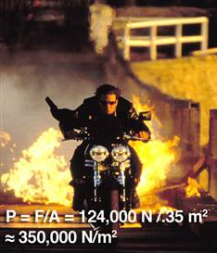
Everett Collection via popsci.com

Collision: Impossible
In a critical scene in John Woo's motorcycle-heavy second installment of the Mission Impossible series, Tom Cruise and evil Dougray Scott have a head-on showdown on their respective high-powered bikes, which ends in a midair collision after each is somehow able to leap off his bike. Neither seems particularly fazed, as the two continue to grapple apparently unhurt on the ground and for the rest of the movie.
Assuming speeds of 50 mph, a collision time of 0.015 second, and masses of 80 and 90 kilograms for Cruise and Scott, respectively, the force generated by the impact is an incredibly large 124,000 newtons, all exerted on the upper-right halves of the combatants' bodies. Estimating the area of impact to be around .35 square meters, we can solve for the amount of pressure exerted on their bodies at the point of impact: 350,000 N/m2. Putting these numbers in real-life terms (what, you don't know what one newton of force feels like?): In car-crash studies, any pressure of that magnitude on the human body results in a 50-50 chance of surviving, with those who do survive coming away with massive internal trauma. Not only do Cruise and Scott survive the initial impact, they don't appear to have even a broken bone between them, when in reality, Tom would need a whole lot of nontraditional healing to recover from this one.

-- Adam Weiner is the author of "Don't Try This at Home! The Physics of Hollywood Movies"
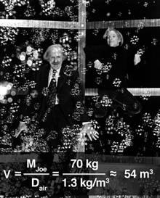
Everett Collection via popsci.com

Weightless in Wonkaville
In "Willy Wonka and the Chocolate Factory," when Charlie and Grandpa Joe sip a bit of Wonka's "fizzy lifting drink" on the sly, they are immediately lifted off their feet and into the air, floating among the bubbles. This, presumably, is the result of all that carbonation inside their stomachs, increasing Grandpa and Charlie's buoyancy to the point where it can overcome the force of their own weight, lifting them into the air.
Thanks to good old Archimedes' principle, we can calculate the amount of air that would need to be displaced to perform the lifting, and thus the necessary increase in volume due to the drink's carbonation of the bodies of Charlie and Grandpa Joe. As you can see, to counteract the force of his mass (here we estimate his mass to be 70 kilograms), Grandpa would have to swell up to a massive 54 cubic meters-if he was a sphere, he would be five meters across (that's over 15 feet). For a more familiar reference, that's at least twice as big as poor Violet's sudden rotundity after sampling Wonka's experimental three-course gum. Which, if you're interested, would need to have a density of 6 x 109 kg/m3 to contain enough juice to fill Violet to the size depicted - that's four or five thousand times the density of an average metal. Watch your fillings!
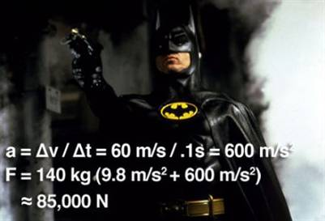
Everett Collection via popsci.com

Batman ... Never?
Falling with Kim Basinger from the top of one of Gotham City's gloomiest bell towers in the first Batman flick, a right-on-the-money shot from Batman's always-trusty grappling hook catches on one of the tower's gargoyles, stopping their fall and saving their lives. If you noted their painfully abrupt and inelastic jerk to a stop, though, you'd be onto something.
With Newton's second law (F=ma), we can calculate just how painful this "life-saving" shot may have been. Assuming a total mass of 140 kilograms for the falling pair, a near-terminal velocity rate of fall of 60 meters per second, and an abrupt 0.1-second stop to zero (yielding an acceleration of 600 m/s2, or 60 times the force of gravity), the force exerted on Batman via the rope is a massive 85,000 newtons, or 60 times the force of gravity: the equivalent of about nine tons. Batman would need to be packing some serious rope to hold up under such a force, but even if the rope didn't snap, a force of that magnitude applied in such a short amount of time would almost certainly break whichever bone the rope was anchored to, on top of causing massive internal injuries. But Batman manages to do it all without even a wince - all the while keeping his grip around his lady's waist. Dreamy!
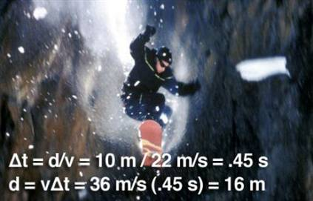
Everett Collection via popsci.com

'XXX': An avalanche of impossibilities
In "XXX," Vin Diesel races an avalanche down the side of a mountain on a snowboard — and wins. Need we say more?
Oh, fine. Let's start with the facts. The fastest recorded run on a snowboard (on a bobsled track, mind you — not loose powder like in the film) is 50 mph. Powder avalanches travel down mountains at officially measured speeds of 130 mph on the low end, topping out at around 200 mph. Even if we give Mr. Diesel the benefit of traveling at an unheard-of 80 mph, and track the avalanche at its slowest possible speed of 130 mph, how long before our totally extreme hero's apparent 10-meter head start is equalized? About half a second. Good luck digging out of that one.
Update: Oops! As some folks in the comments have pointed out, the fastest recorded run on a snowboard is actually upwards of 125 mph (set by Darren Powell in 1999). But still, considering an avalanche can travel anywhere between 130 and 200mph and an obvious lack of an aerodynamic helmet (or skin-tight speed suit, thankfully) on Vin, our money is still on the avalanche.
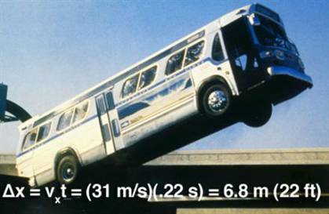
Everett Collection via popsci.com

'Speed': Quick -- learn some physics!
Let's talk about the marquee scene: A passenger bus successfully ramping a disastrous-looking 50-foot-plus gap in the freeway? Unlikely as that is in itself, we as viewers are also treated to a direct shot of the gap in question, which clearly shows that the incline of the highway at the point of the jump is practically nil. Hmm, so what exactly is keeping the bus from simply walking the plank, dropping to its fiery doom below?
A good question. At the time of the jump, Sandra Bullock manages to get the bus honking up to 70 mph, which means that in the time it takes to span the flat, 50-foot gap, the forces of gravity will have pulled the bus down at least 3.5 feet below the level of the bridge.
Even given a set of impossibly ideal conditions — an optimistic two-degree incline in the road and disregarding air resistance altogether, the bus's rise and fall as a projectile will still only last around 0.22 second after leaving the ramp. How much ground could the bus cover in 0.22 second? About 22 feet, or less than half the length of the gap. Boom!

NASA / JPL-Caltech / Univ. of Michigan

Sound in space
The most frequent sci-fi physics sin is, without a doubt, the incredible sounds emitted by all those zooming spacecraft, all those exploding planets, all those laser beams whizzing by.
As every student learns very early on, sound waves need a medium through which to pass in the form of vibrations to be heard. Air, water, the membrane of your eardrum — all are sufficient media to transmit these vibrations. And as we all know, the cold vacuum of space is unfortunately devoid of anything substantial enough to serve as a transmissive medium. It's true, however, that those unfortunate enough to have their spacecraft destroyed while it was exploding would certainly hear quite a racket for a few split seconds from inside, as the sound vibrations passed through the ship itself and into what was left of the cockpit's pressurized atmosphere as it broke up. But once the damage was done, we'd be back to space's normal, somber silence. But hey, I guess all those sound designers and THX-equipped theaters need to be used for something, right?
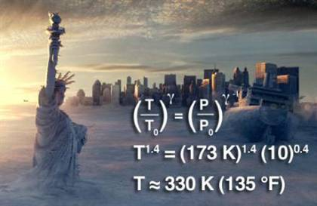
Everett Collection via popsci.com

Deep freeze from above
In "The Day after Tomorrow," the scariest antagonists (besides the alien zombie dogs on board the abandoned cargo ship) are the roving "hurricanes" of sub-zero air that put anything that falls below the "eye" of the storm into a deep freeze. In the film, these storms are said to derive their freeze-ray powers by rapidly sucking cold air (-100C) down from the Earth's troposphere to the surface.
But what Dennis Quaid's professor character failed to consider was that the atmospheric pressure in the upper troposphere is roughly one-tenth of what it is on the surface. As air falls to the surface and its pressure increases, its volume will decrease, as decreed by Boyle's law. Air masses are excellent insulators and relatively little energy, will leave the system during this volume change. Because of the first law of thermodynamics, the work done to compress the air will be converted into energy, thus raising the temperature. How much? Under ideal conditions, the –100C air would be warmed to a scorching 57C (135F) by the time it reached the surface. Under more conservative real-world conditions (accounting for some loss of energy from the system and the un-ideal nature of the atmosphere's gases), that figure would be around 0C, or a cool yet by no means freeze-ray-capable 32F.

Everett Collection via popsci.com

'Enemy of the State': Right! Faraday cage
Kudos to another unlikely laws-of-physics abider: the Will Smith vehicle "Enemy of the State." In it, a kooky ex-National Security Agency operative played by Gene Hackman lives and works in something he calls "the Jar," a structure surrounded by a copper mesh that he claims keeps the NSA's prying eyes off him because of its imperviousness to radio frequencies.
As you've probably discovered yourself while in a building constructed with certain types of reinforced concrete, some materials have a knack for soaking up static electrical fields and sapping your cell phone reception — and copper is one of them. Whether built intentionally or not, this type of metallic shield is called a Faraday cage, after lifetime physics-hall-of-fame member Michael Faraday. Put simply, copper's conductivity effectively cancels out most electrical fields that come into contact with it, keeping the area inside a radio-free zone. Since the mesh surrounding Hackman's "Jar" is particularly fine, and because most radio and television waves have a wavelength of five meters or more, they aren't able to penetrate. Come on in, Will, you're safe here!
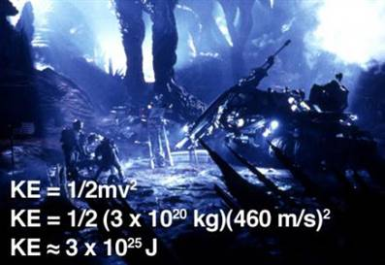
Everett Collection via popsci.com

'Armageddon': Last by a long shot
Oh "Armageddon," where do we begin? Brought to us by master-of-realism Michael Bay, this 1998 film is among cinema's worst physics offenders. Let's try to tackle one of its most hilarious distortions of reality, the one at its core — that a nuclear warhead placed on an asteroid the size of Texas could successfully blow it apart, preventing a catastrophic collision with Earth.
Let's ignore the fact that asteroids don't have fault lines, and if they did, they would not be easily detectable. Let's also put aside the fact that the prescribed 800-foot-deep hole in a Lone Star–size asteroid (Texas is 700 miles wide) would barely even scratch the surface, only getting you 0.0004 percent of the way to the center. Or that Bruce Willis and friends miss their landing site by 26 miles, presumably putting them away from the "fault line" anyway. Let's just focus on the amount of kinetic energy needed to blow an asteroid apart, and for its two massive halves to move far enough (one Earth-radius perpendicular to the impact trajectory) to miss the Earth in the three hour and 56 minute time frame that marks this mission's absolute deadline.
Granted, this calculation assumes a ton of ideal conditions, which almost certainly wouldn't exist. But even in a perfect scenario, a certain kinetic energy would be necessary to separate the asteroid halves and propel them at the required 460 m/s. The biggest warhead built to date has a yield of 100 megatons. That's one one-hundred-millionth of the energy Bruce would need to save Earth — making this flick a bomb in more ways than one.
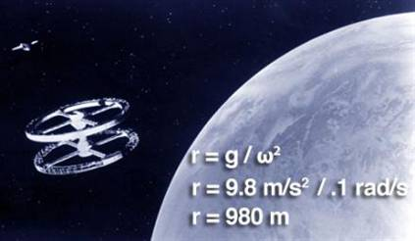
Everett Collection via popsci.com

'2001: A Space Odyssey': Right! Rotational gravity
(Very) occasionally, a movie comes along that not only avoids completely defrauding the realities of the physical world but actually manages to get things mostly right. Most famous among these stellar students, especially in the sci-fi genre, is Stanley Kubrick and Arthur C. Clarke's "2001: A Space Odyssey."
One of the concepts the film manages to tackle with accuracy is artificial rotational gravity. In the famous opening segue from a prehistoric monkey battle to the space age, we see a giant circular space station slowly revolving. Inside, people can walk and sit in chairs just like on Earth. The shot stays put long enough to note that the station appears to be spinning at around one revolution per minute.
Now, to simulate gravity, the centripetal acceleration created by the rotation must be equal to the acceleration due to gravity on Earth, or 9.8 m/s2. The radius of rotation also needs to be large enough for there to be minimal difference between the relative rotational velocity of a person's head and feet (something that — again — "Armageddon" fails to take into account). A quick calculation based on the 1rpm speed requires that the station have a diameter of 980 meters, or about the size of 10 football fields - huge, yes, but shown as such in the film. So you can't fault them for that.
Oh, and this film portrays the silence of space better than any other I've seen. Bravo.

Updated: 9:56 a.m. ET Apr. 6, 2008
© 2008 MSNBC.com
URL: http://www.msnbc.msn.com/id/23943370/?pg=1#HOLLYwoodphysics_popsci

