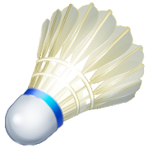

MAKE-UP ASSIGNMENTS

Identify the following badminton terms: (1 make-up = defining 6 terms)
PICTURE AND EXPLANATION ARE REQUIRED!

- CARRY

- CLEAR

- CROSSCOURT

- DRIVE

- DROPSHOT

- FAULT

- FLICK

- HAIRPIN

- LET

- SERVICE AREA

- SHUTTLECOCK

- SMASH

Make up a lead-up game to badminton. Your game must include:

    - Shuttlecocks
    - Racquets
    - 2 other pieces of equipment

-Give Description of game.
-What are the rules of the game?
-Draw the set-up for the game.

