1. Tina had at least 50 people attend the family reunion she planned for Thanksgiving this year. Which inequality and graph represents the situation?

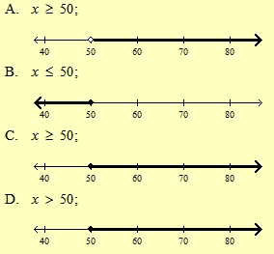

1. Which graph represents the solution to the inequality below?

$$\frac{x}{-4}+3<7$$

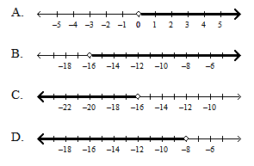

1. Erica charges $12 for each hour, *x*, she babysits plus $4 for bus fare. Next weekend, Erica wants to earn at least $40 while babysitting. Which graph shows all the possible number of hours she could work to earn that amount?
2. 
3. 
4. 
5. 
6. Lisa works for Gmax Real Estate Agency. Each month she earns $2,000 plus 5% of the selling price of each house sold. She wants to earn more than $60,000 this year. Which inequality represents the possible combined selling price (*x*) of all the houses sold during the year for Lisa to meet her goal?
$x>11,600$

$x>180,000$

$x>720,000$

$x>1,160,000$

7. This winter the high temperature in a town in Alaska was 2°F lower than seven times the low temperature in that town. If the high temperature is less than 19°F, which graph could represent *x*, all the possible low temperatures in the town?
8. 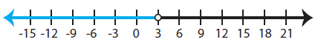
9. 
10. 
11. 
12. Jenny’s mom want to rent a limousine for a trip to the city for her birthday. The limo costs $700 for the night and $0.40 per mile. She has $750 to spend. Write an inequality that represents this scenario. How many miles can the limo travel?
13. 125 miles or more
14. No more than 125 miles
15. Less than 20 miles
16. Exactly 125 miles
17. Maurice is taking a vacation over spring break.
18. Before the vacation, in order to save some spending money, he would like to earn at least $1000 each week. As a salesman, he earns $750 a week plus 10% of his sales. How much does Maurice need to make in sales to meet his goal? Write and solve an inequality. Show your work.